**Cloud Trail**   
It is a service that enables governance, compliance, operational auditing, and risk auditing of your AWS account. It continuously logs and monitors the activities and actions across your AWS account. It also provides the event history of your AWS account including information about who is accessing your AWS services.

**Difference between AWS Cloudwatch and AWS Cloudtrail :**

|  |  |  |
| --- | --- | --- |
| S.No. | AWS Cloudwatch | AWS Cloudtrail |
| 1. | It is mainly concerned with happenings on AWS resources. | It is mainly concerned with what is done on AWS and by whom. |
| 2. | It is a monitoring service for AWS resources and applications. | It records API activity in the AWS account. |
| 3. | Using Cloudwatch you can track metrics and monitor log files. You can also set alarm for various events. | CloudTrail provides greater visibility into user activity by tracking AWS console actions including who made the call, from which IP address and when. |
| 4. | It specifically records the application logs. | It provides information about what occurred in your AWS account. |
| 5. | It delivers metric data in 1 minute period for detailed monitoring and 5 minute periods for basic monitoring. | It delivers an event within 15 minutes of the API call. |
| 6. | It stores data in its own dashboard in the form of metrics and logs. | It can centralize all the logs across regions and even across many accounts and store them on S3 bucket. |
| 7. | It offers free basic monitoring resources by default, such as EC2 instances, RDS, etc. | It is enabled by default when AWS account is created and start working from then. |

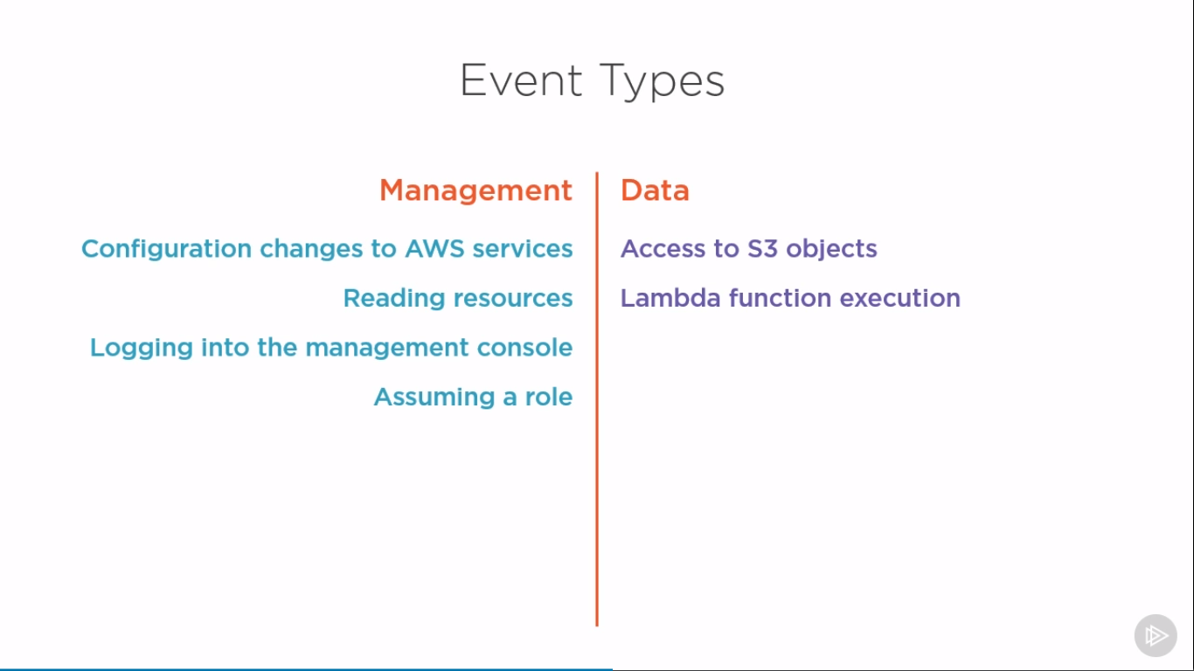

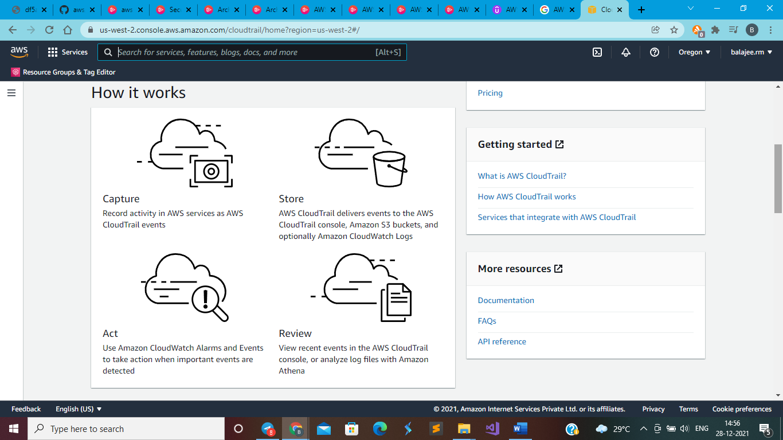

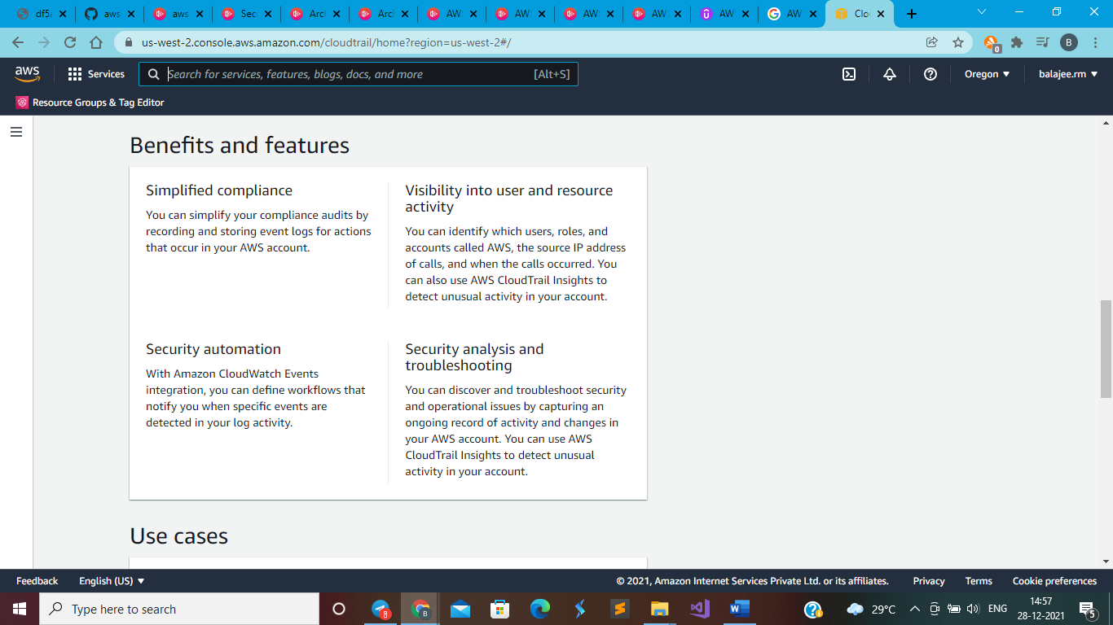

Free Tier

Get started with AWS CloudTrail for free, with the [AWS Free Tier](https://aws.amazon.com/free/).

Log and search events with Event History

AWS CloudTrail logs management events across AWS services by default. You can view, search, and download the most recent 90-day history of your account’s management events for free using CloudTrail in the AWS console or the AWS CLI Lookup API.

Deliver events by creating trails

Deliver one copy of your ongoing management events to Amazon S3 for free by creating trails. This lets you store S3 events for the past 90 days.

**Encrypting Data**

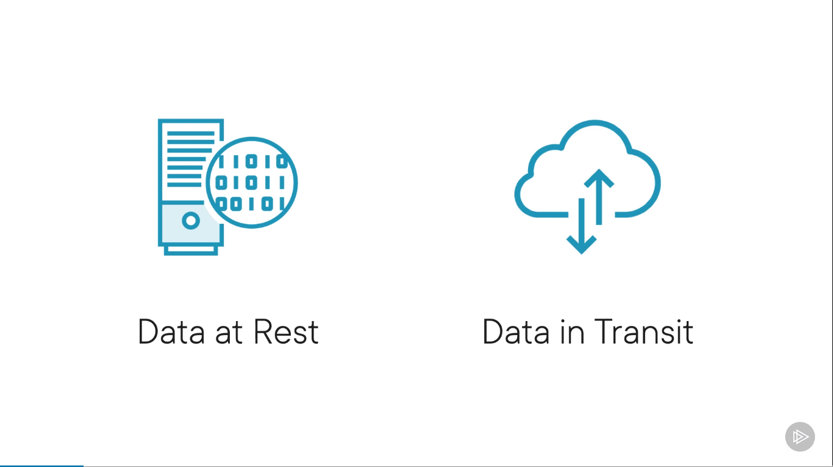

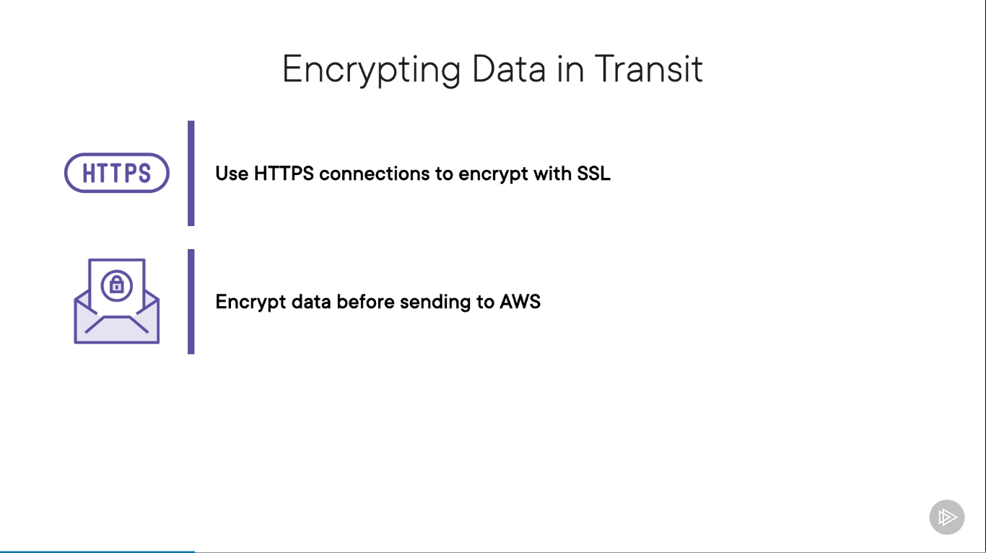

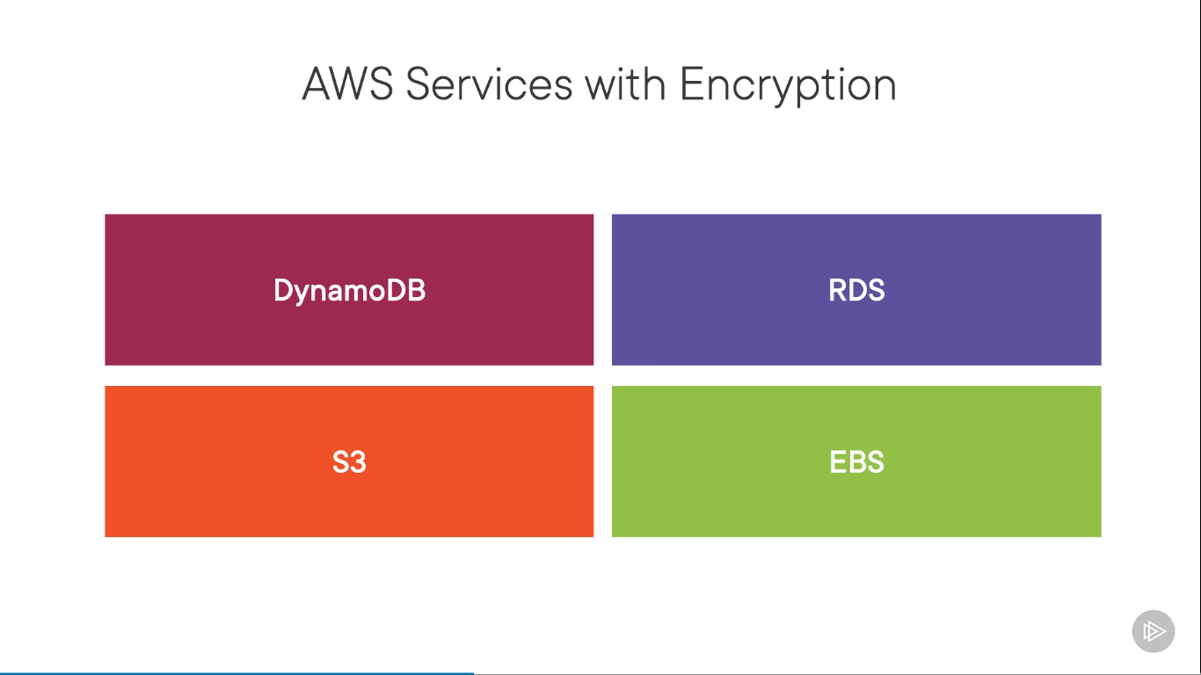

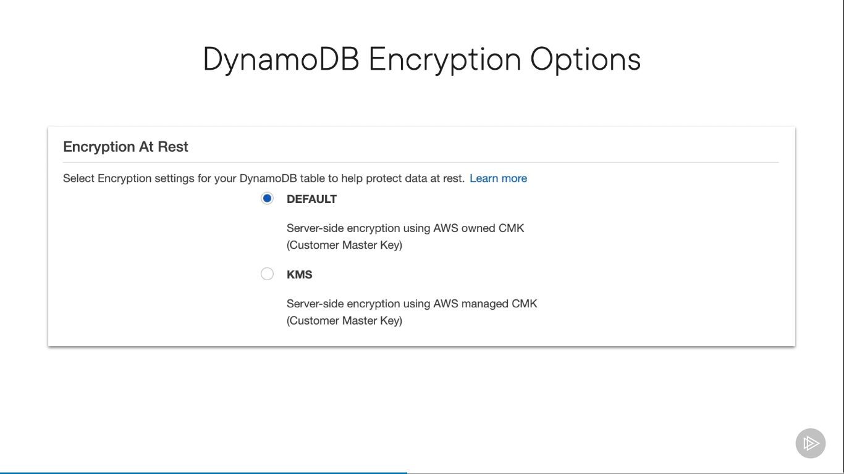

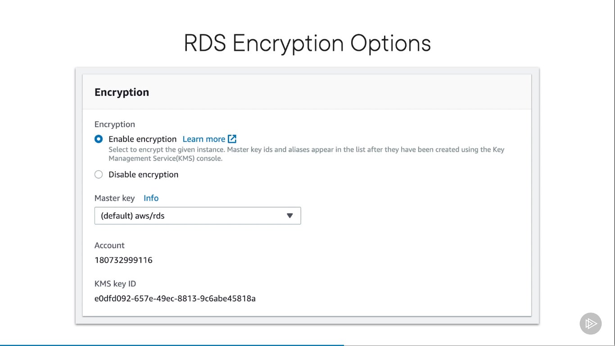

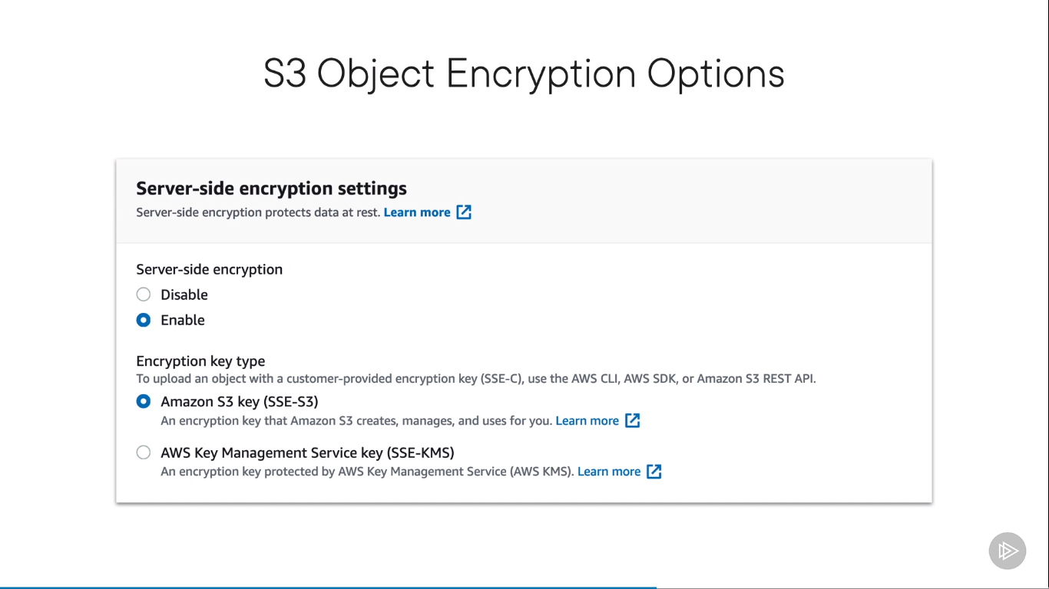

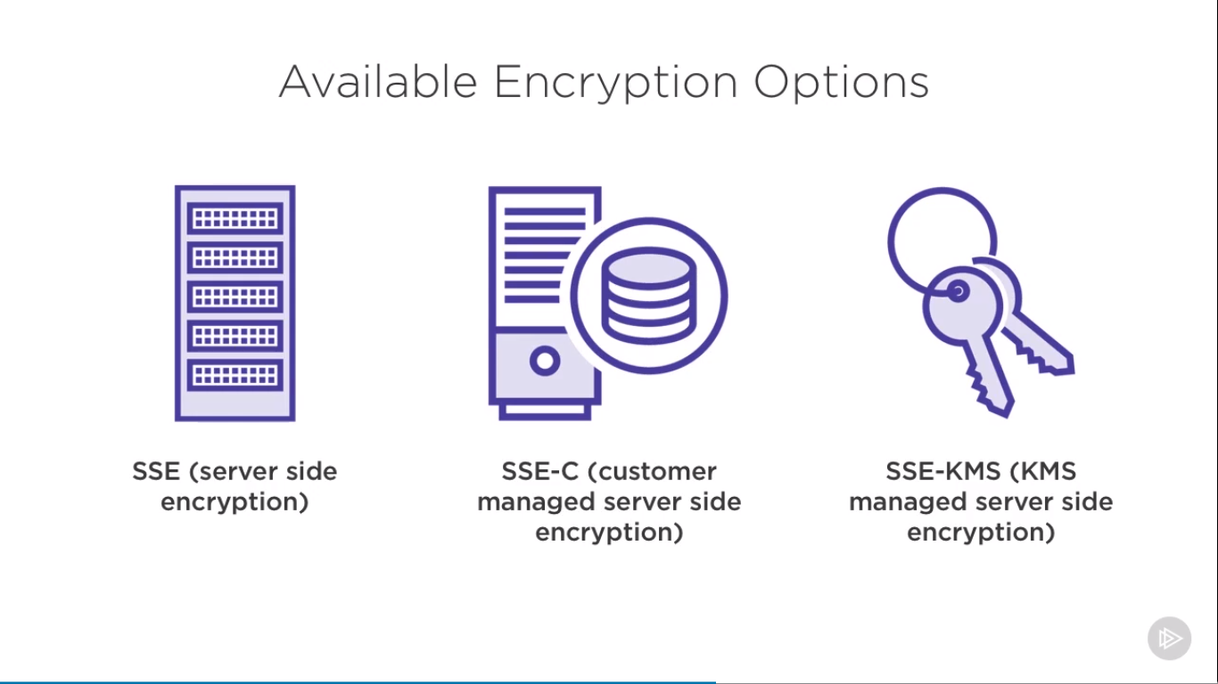

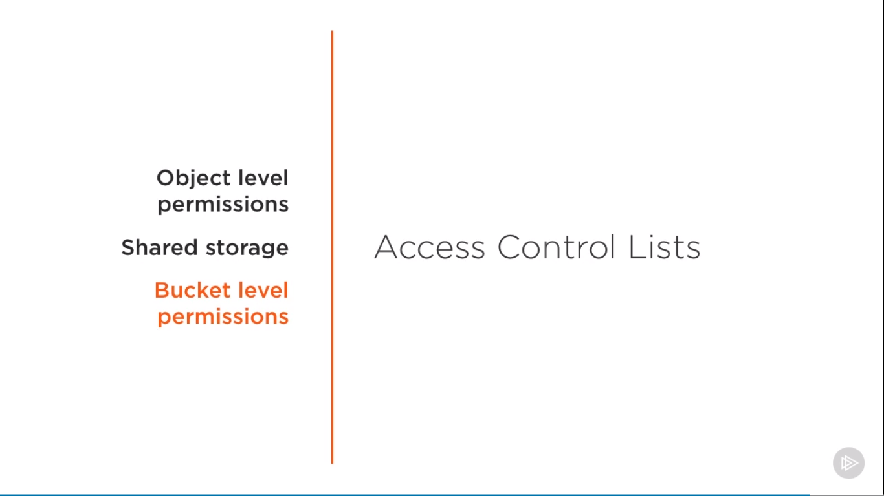

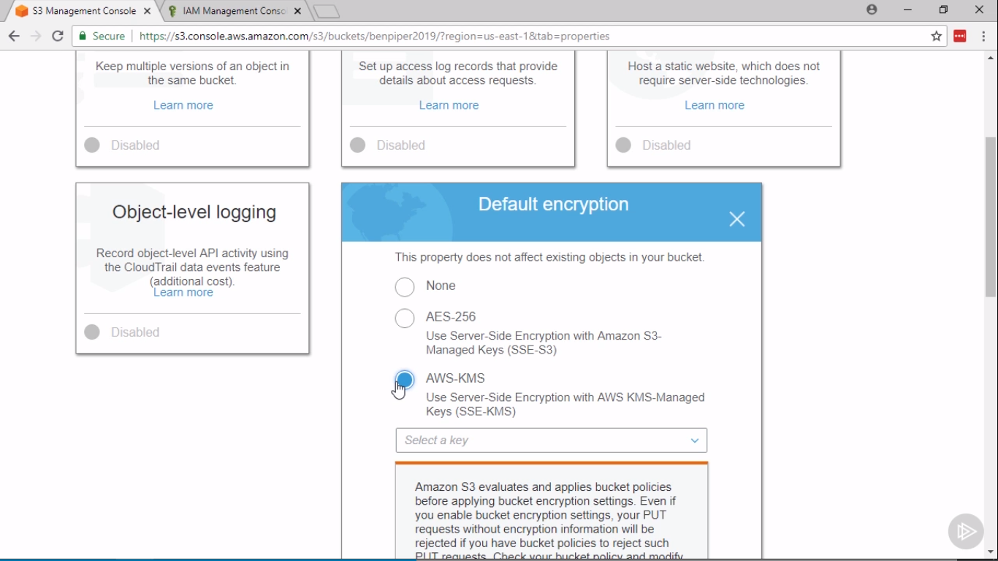

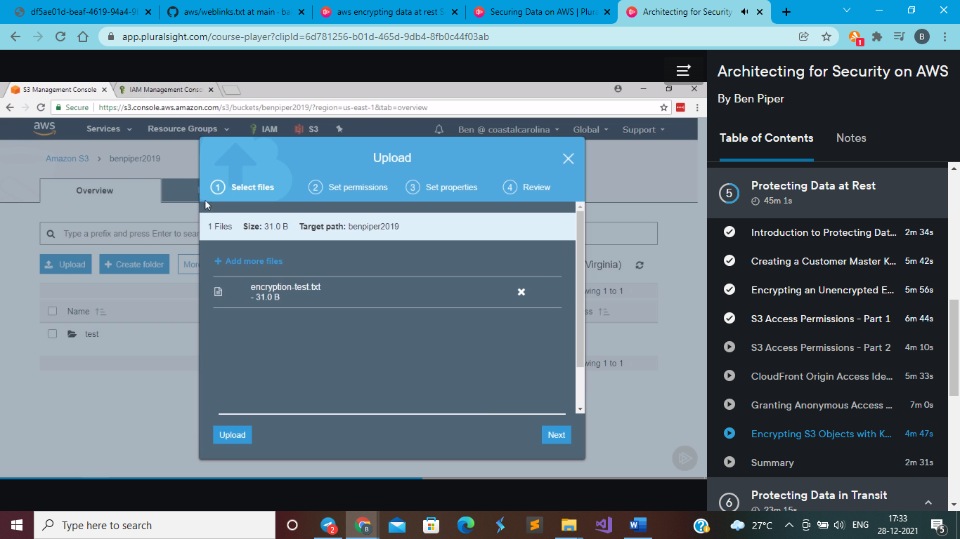

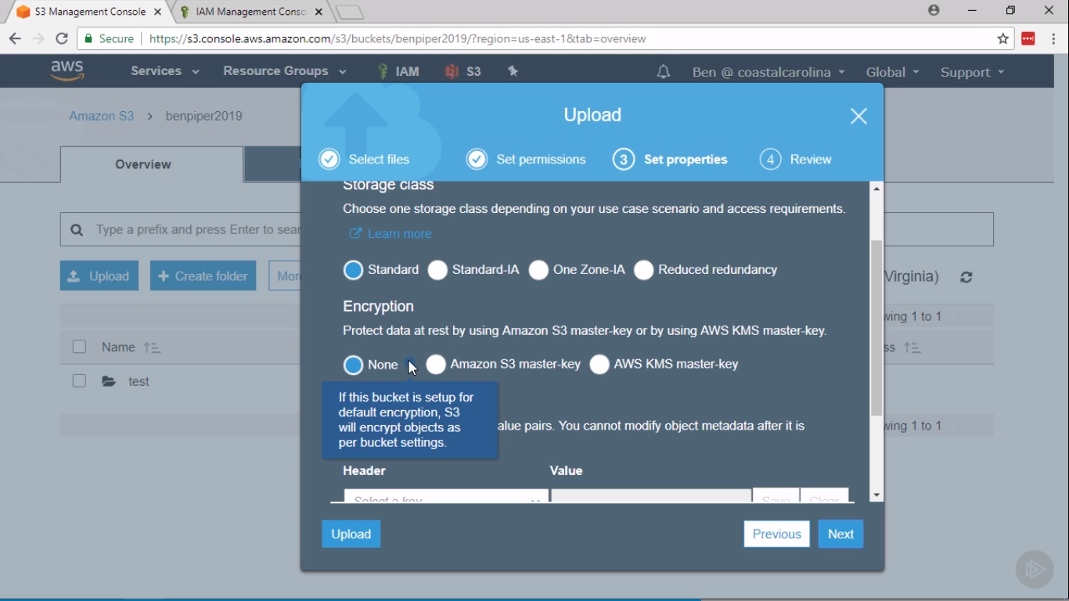

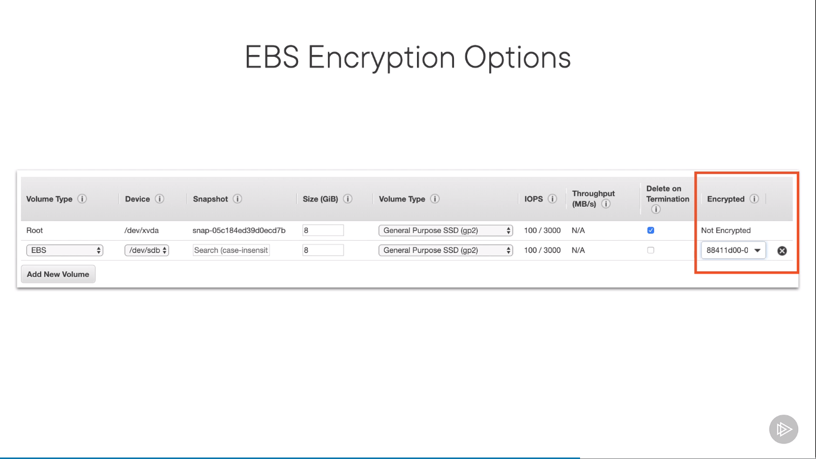

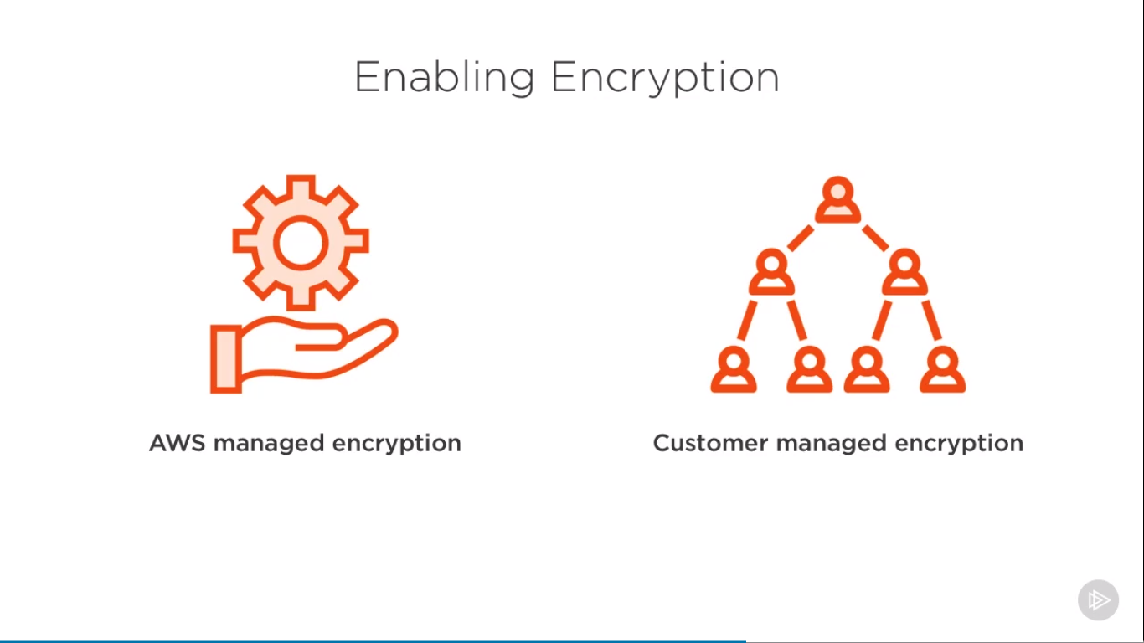

**You can not change encryption key after volume is created**

**The original EBS volume can not be encrypted, we can encrypt the snapshots**

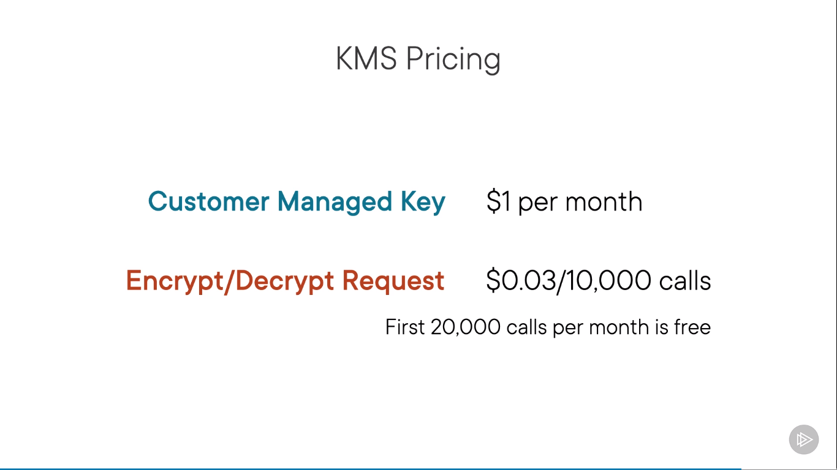

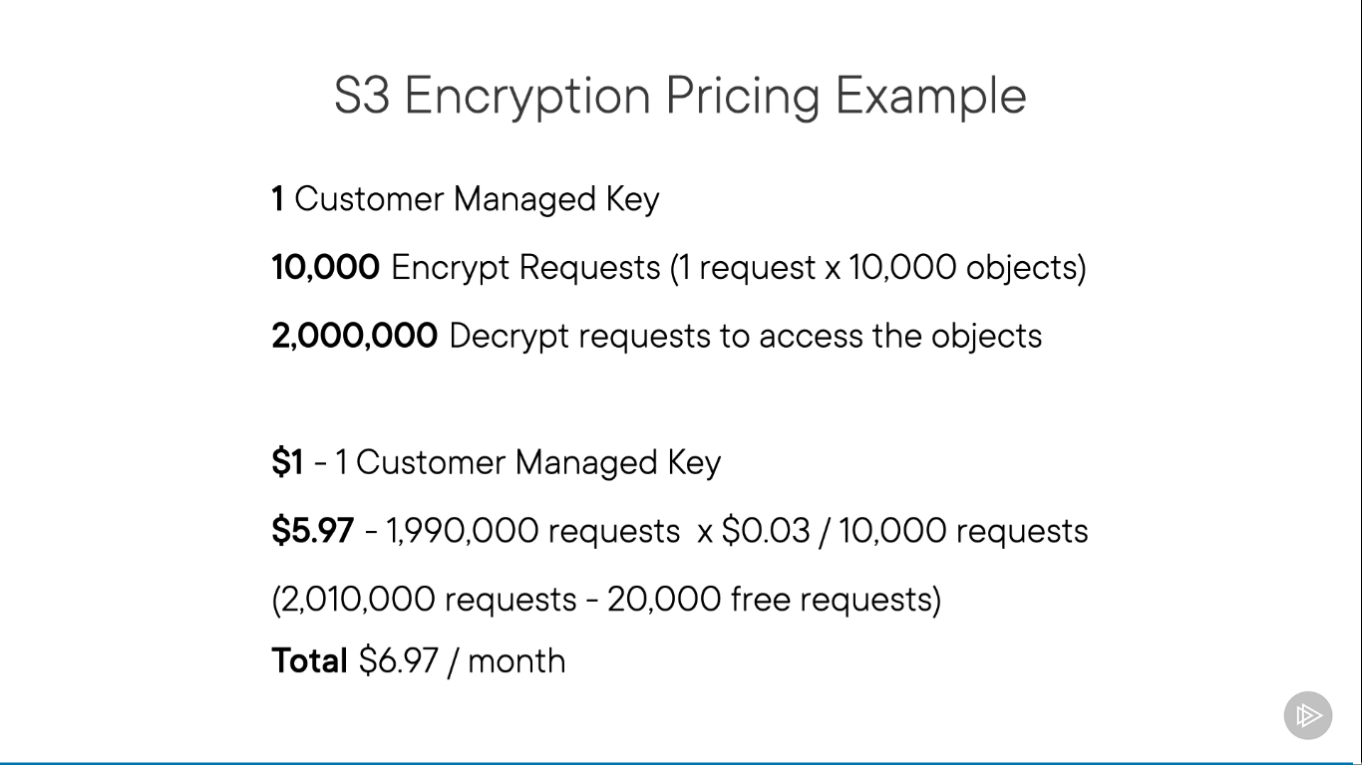

**KMS**

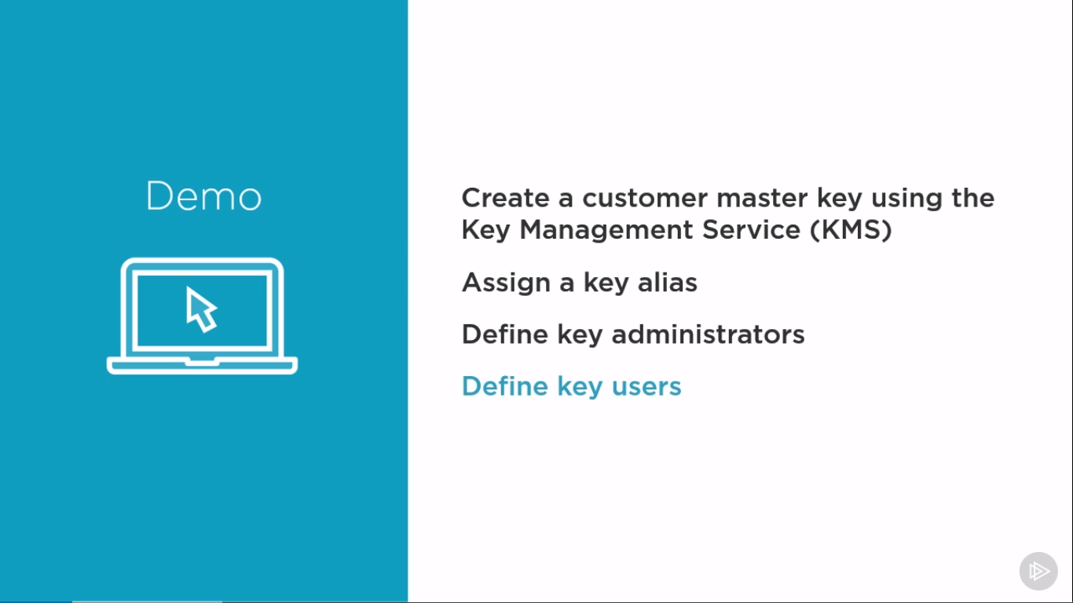

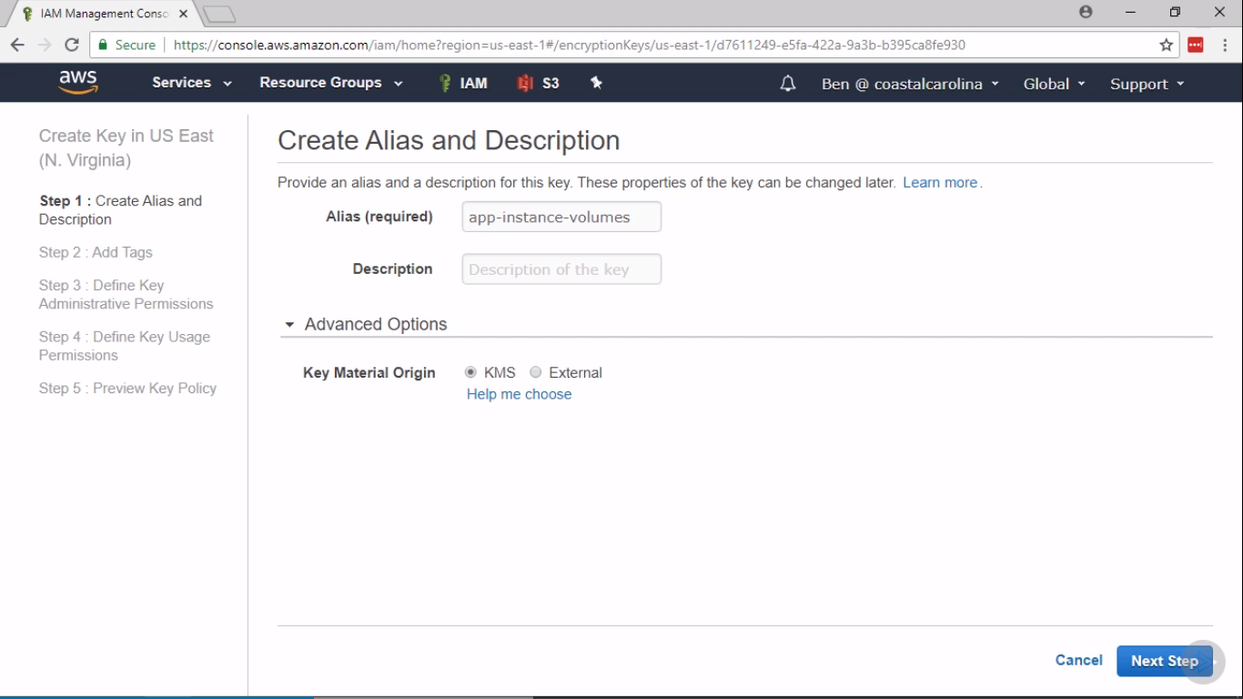

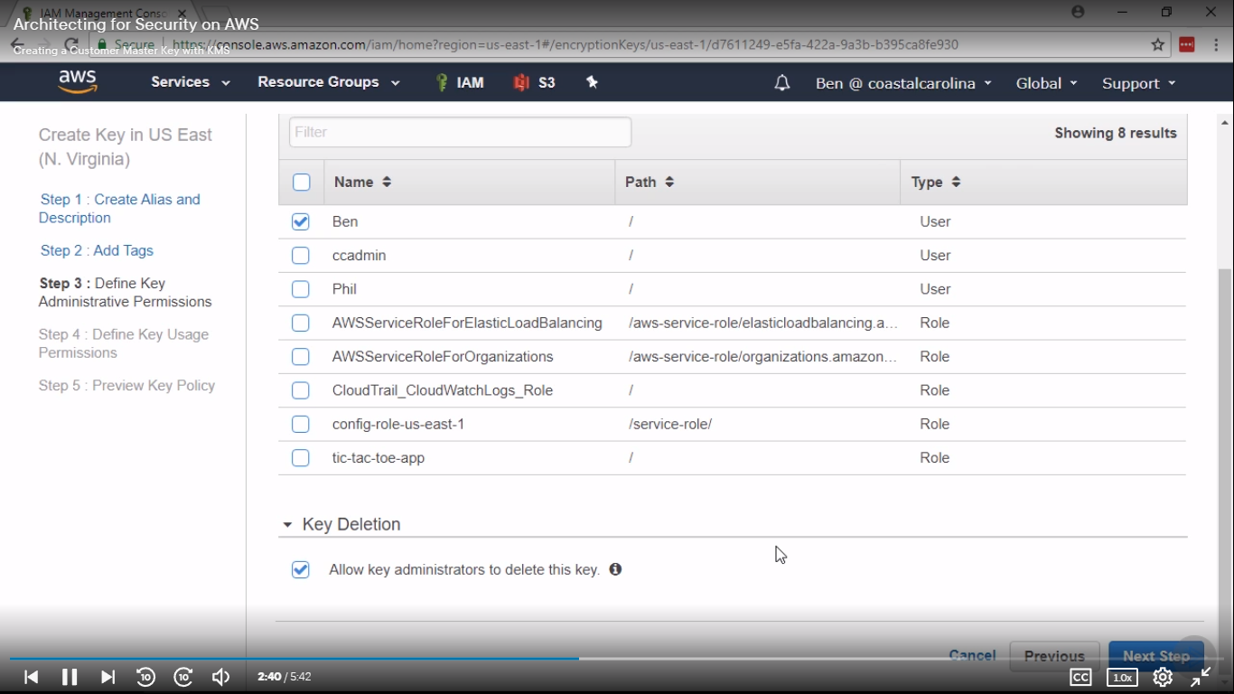

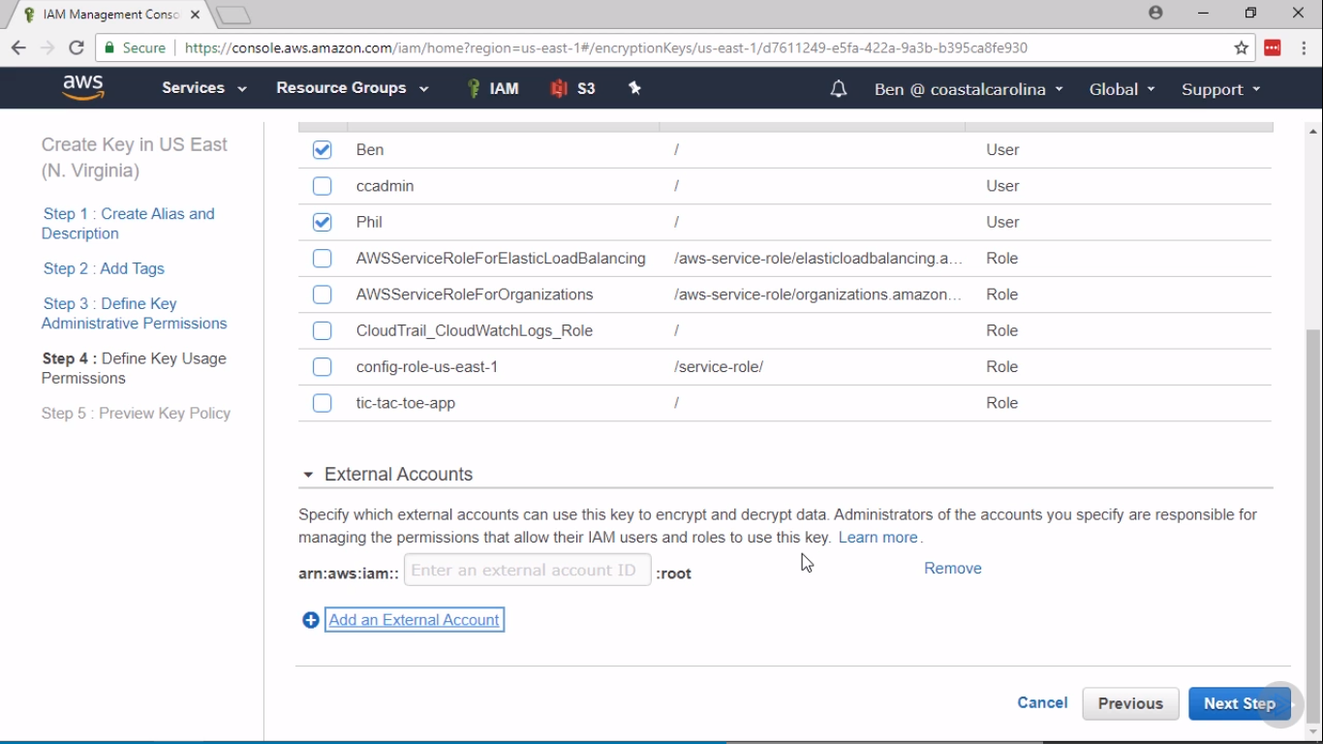

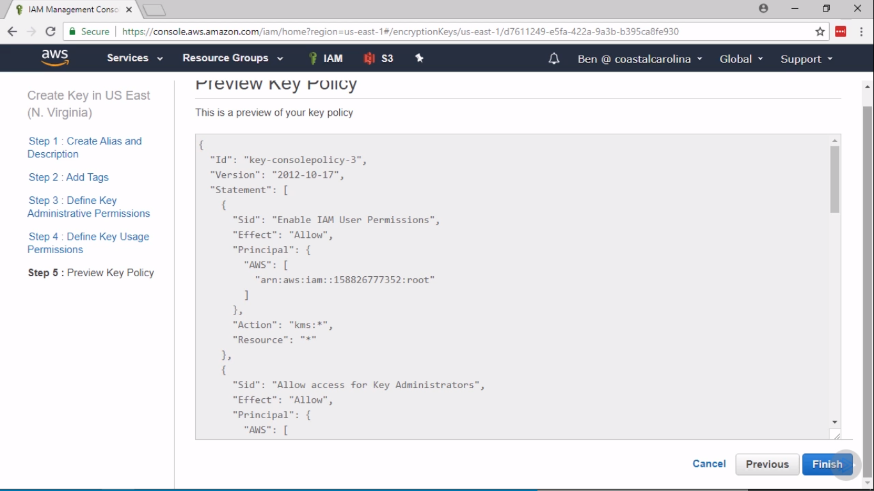

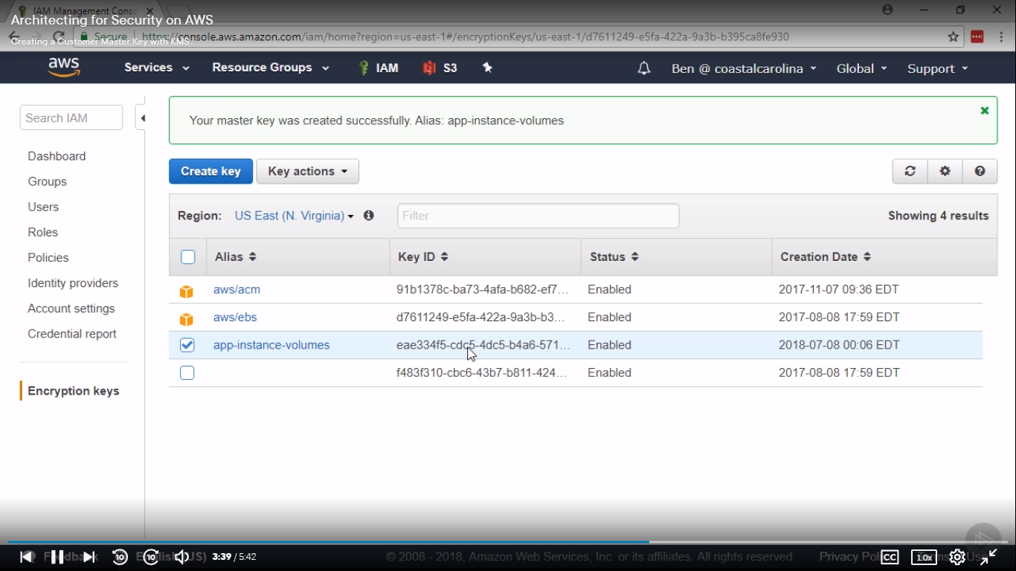

**Cloud Formation and Elastic Beanstalk**

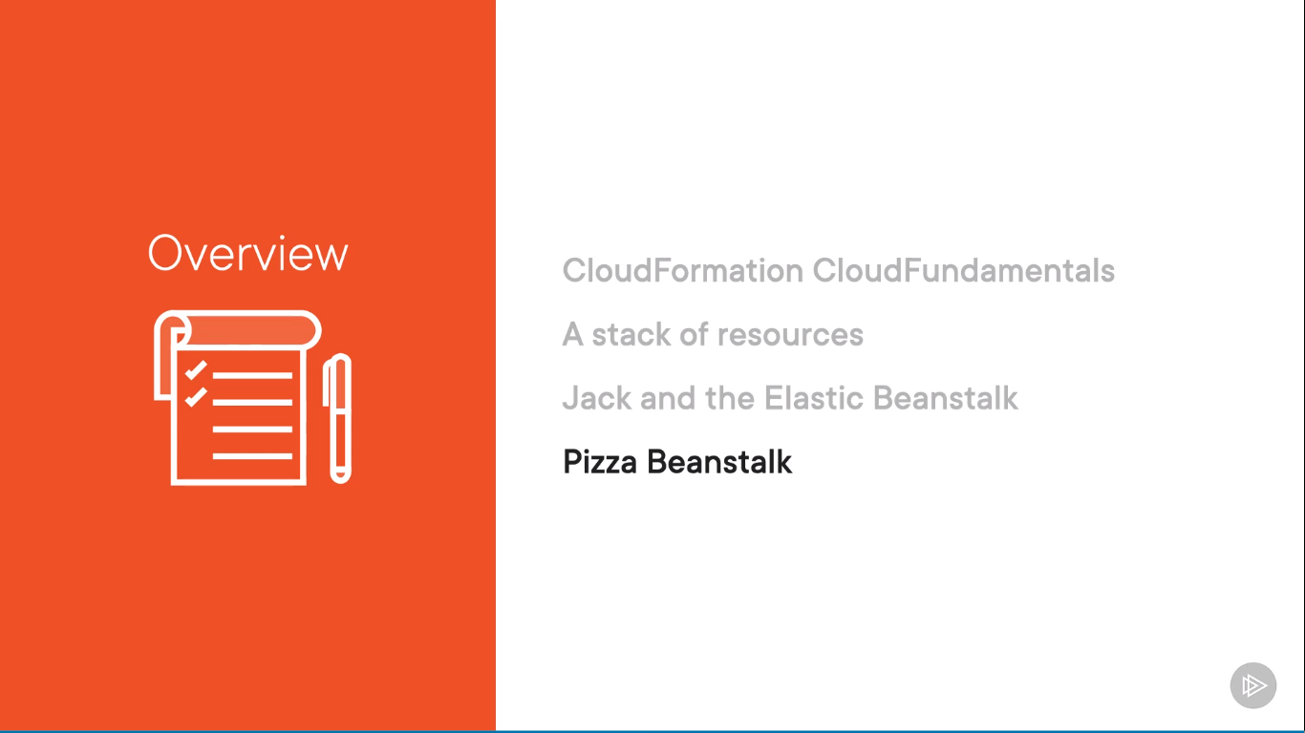

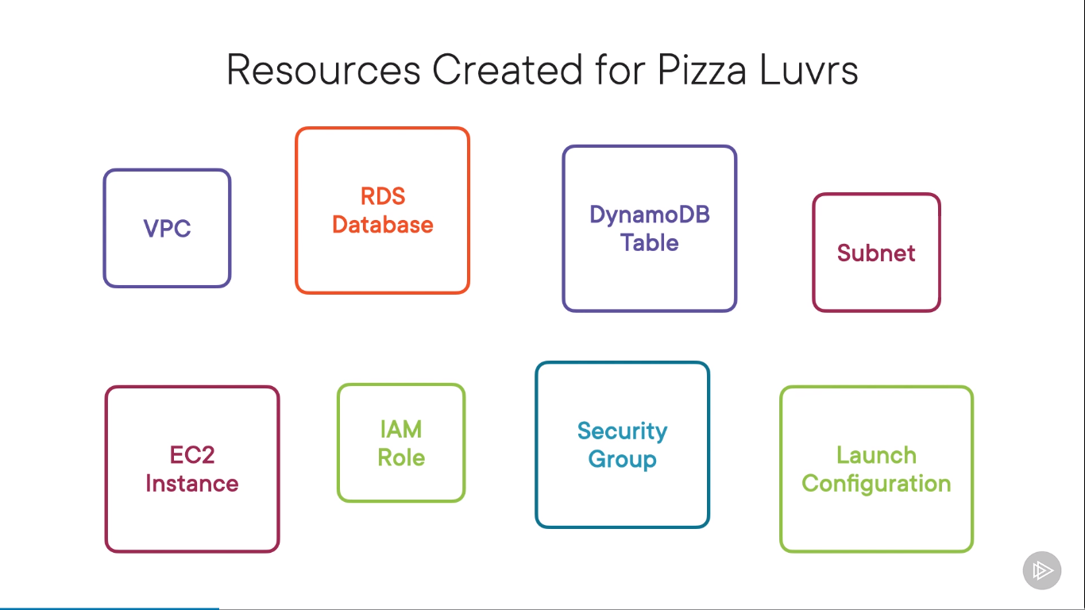

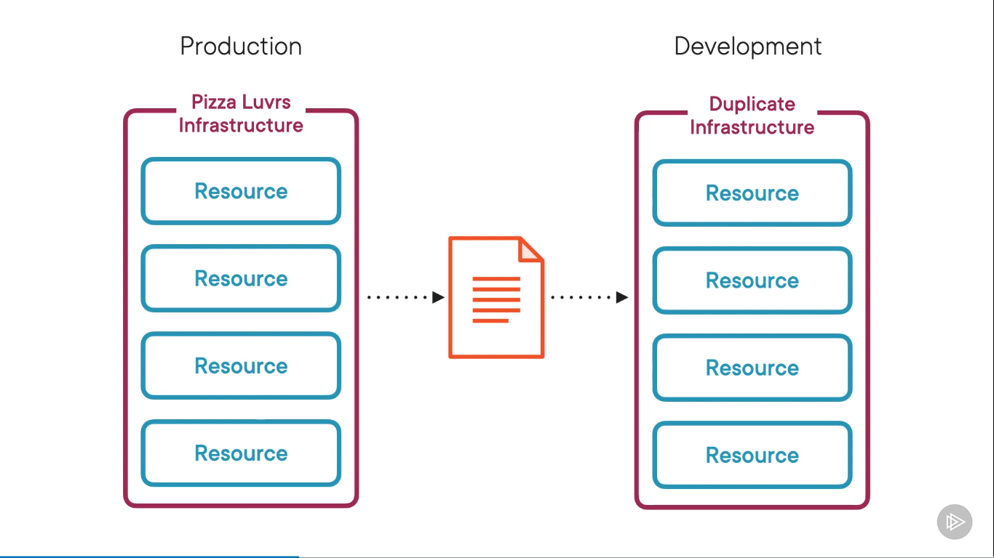

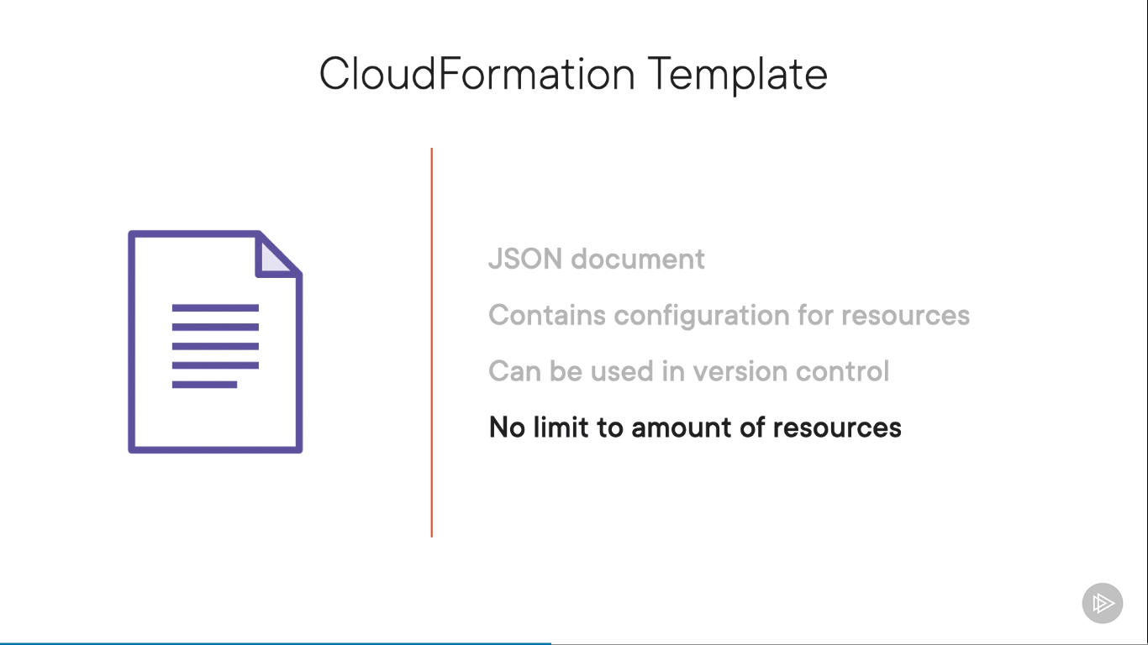

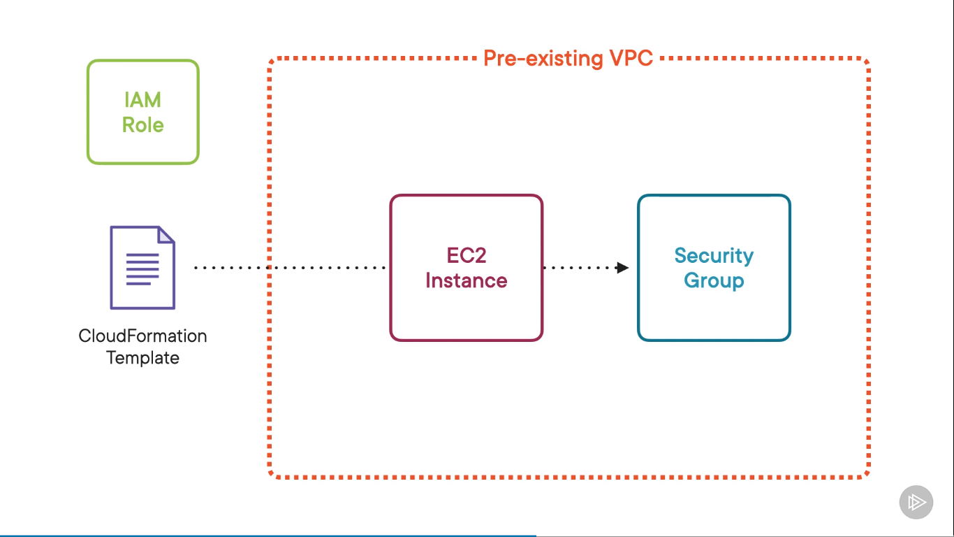

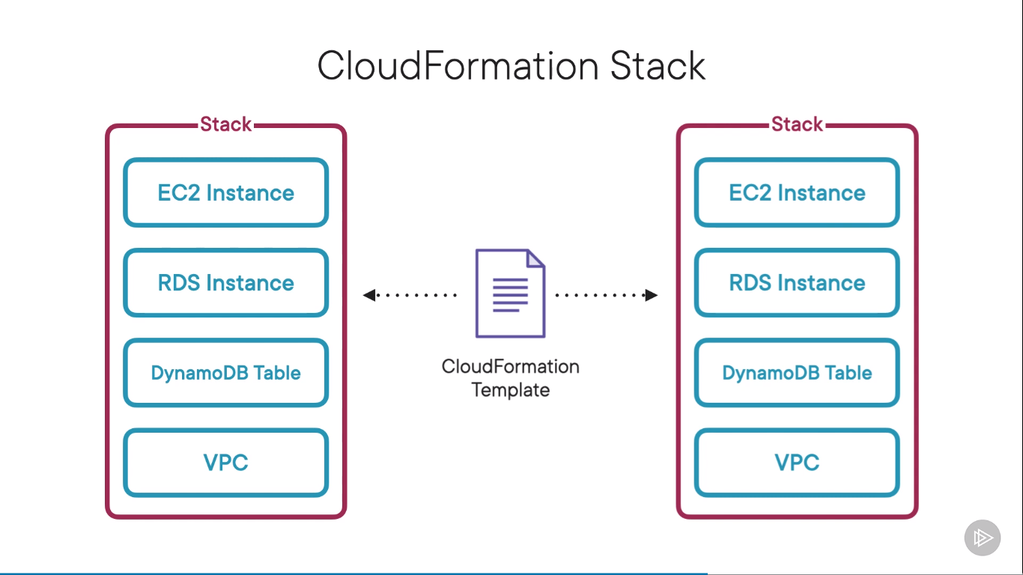

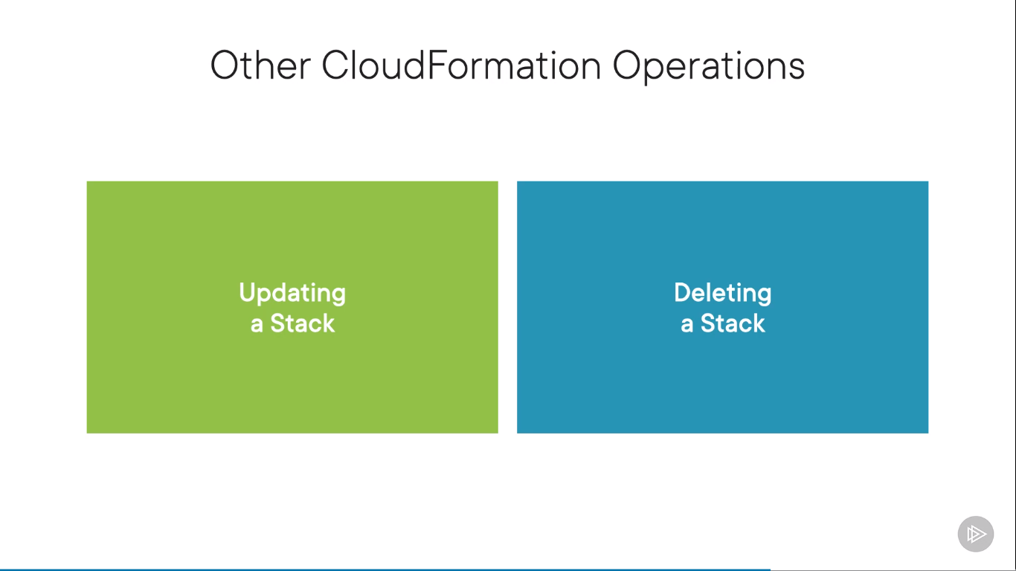



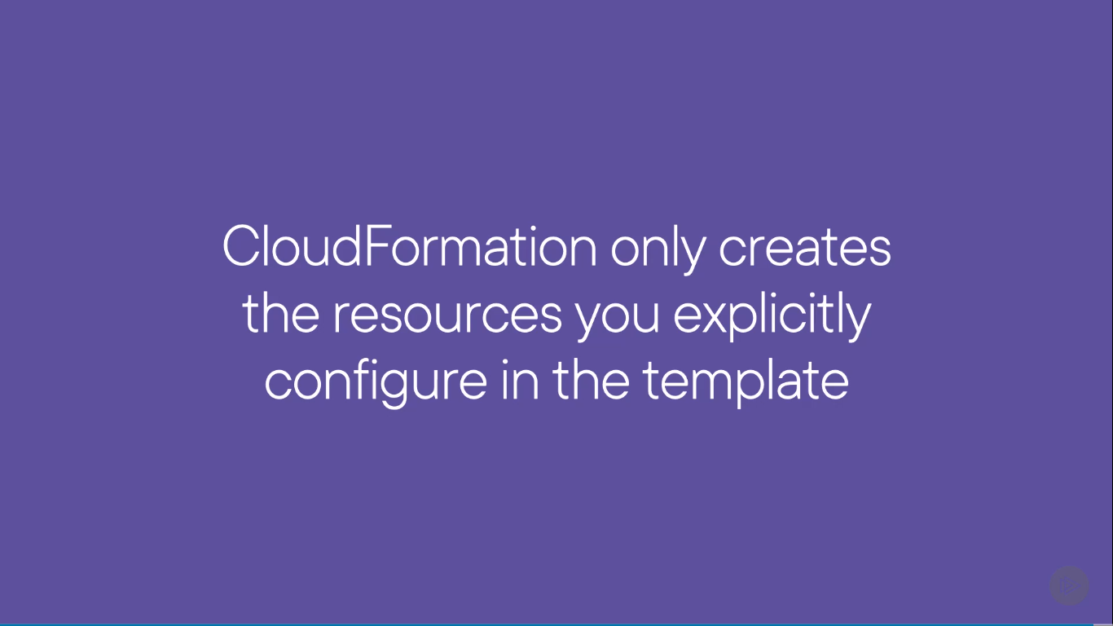

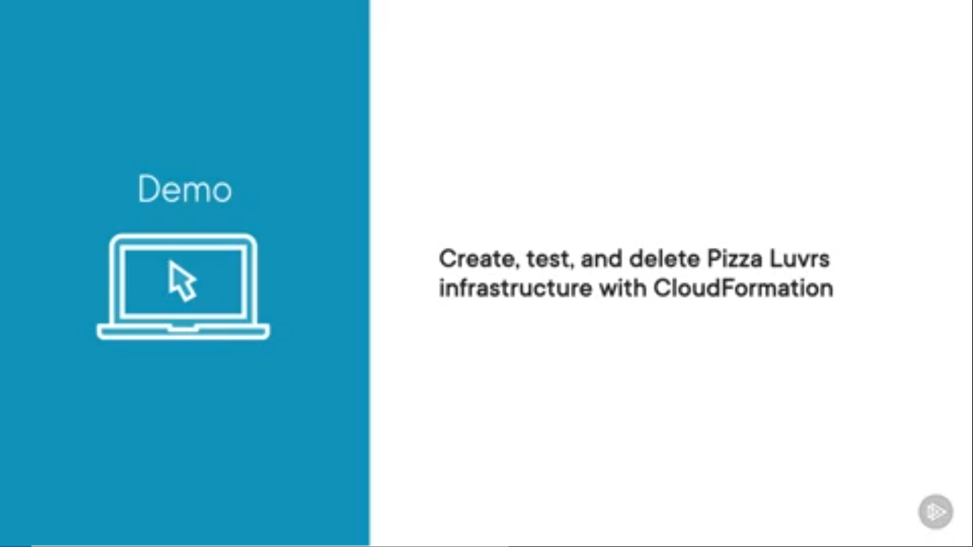

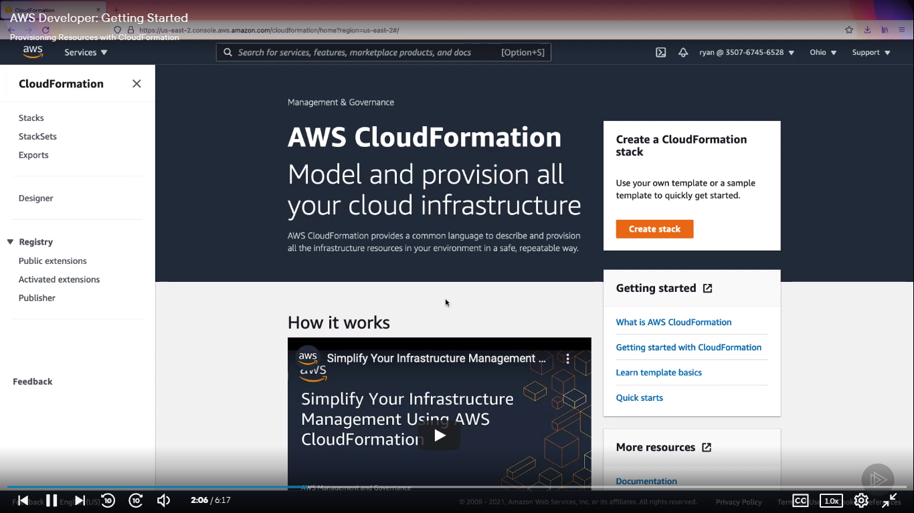

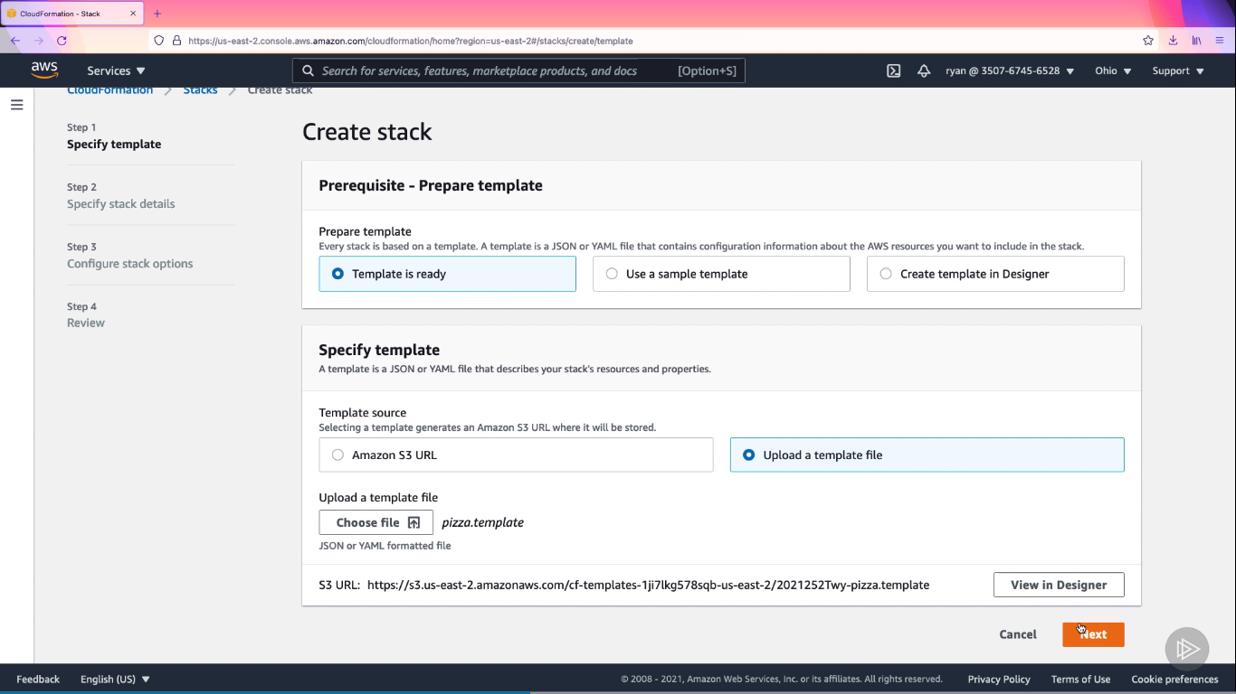

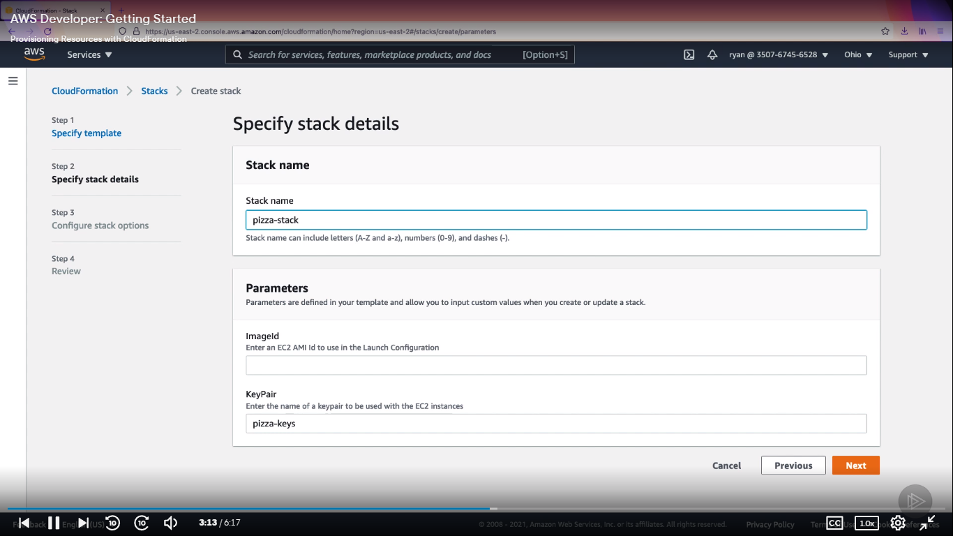

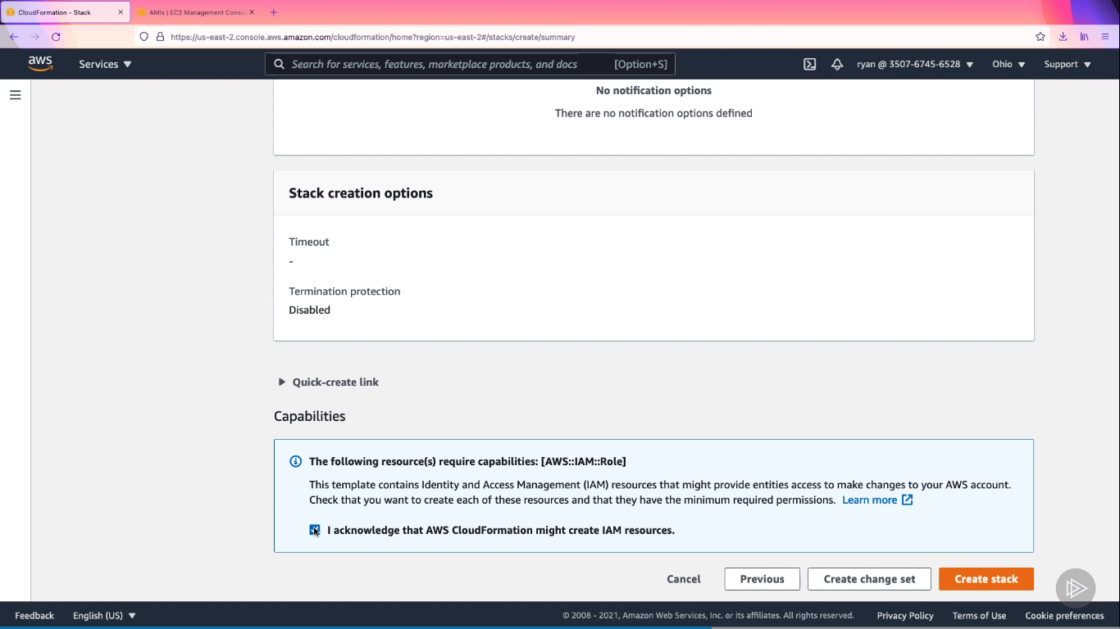

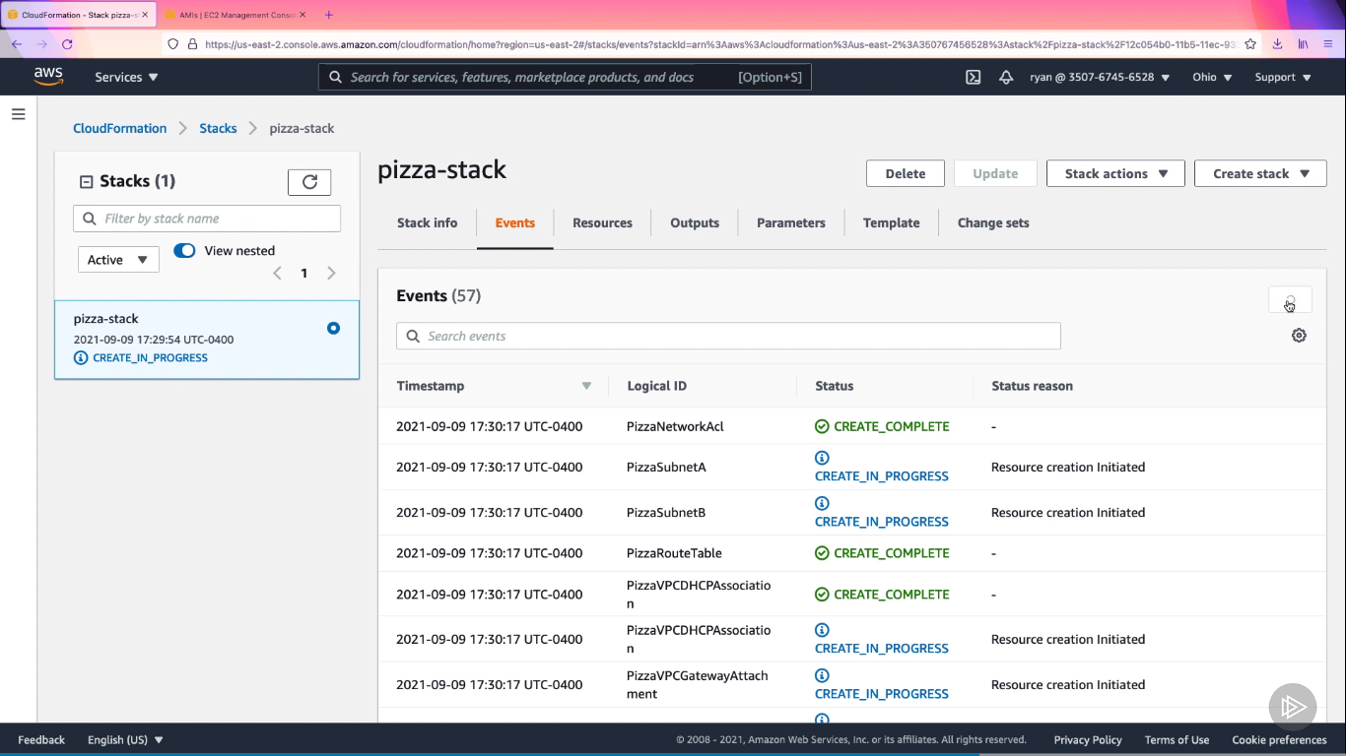

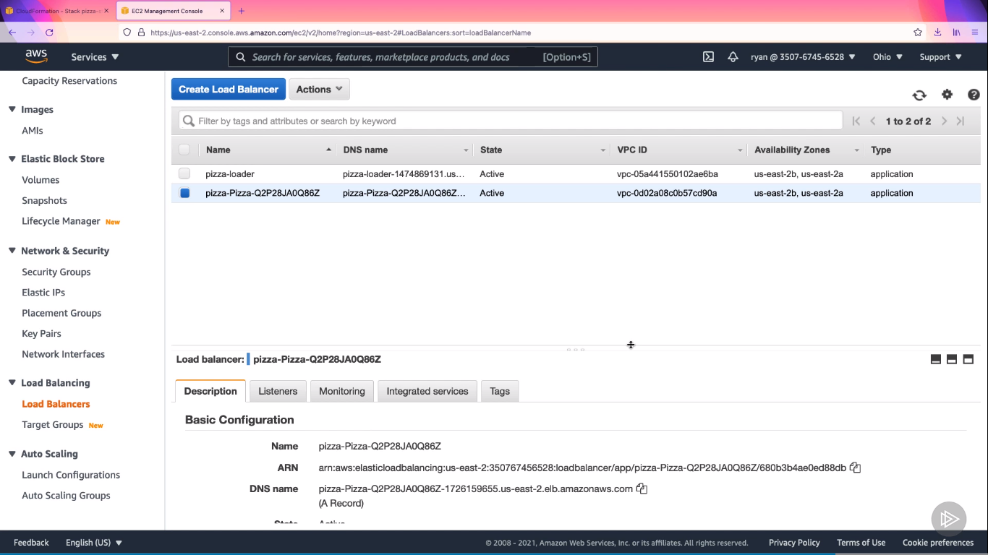



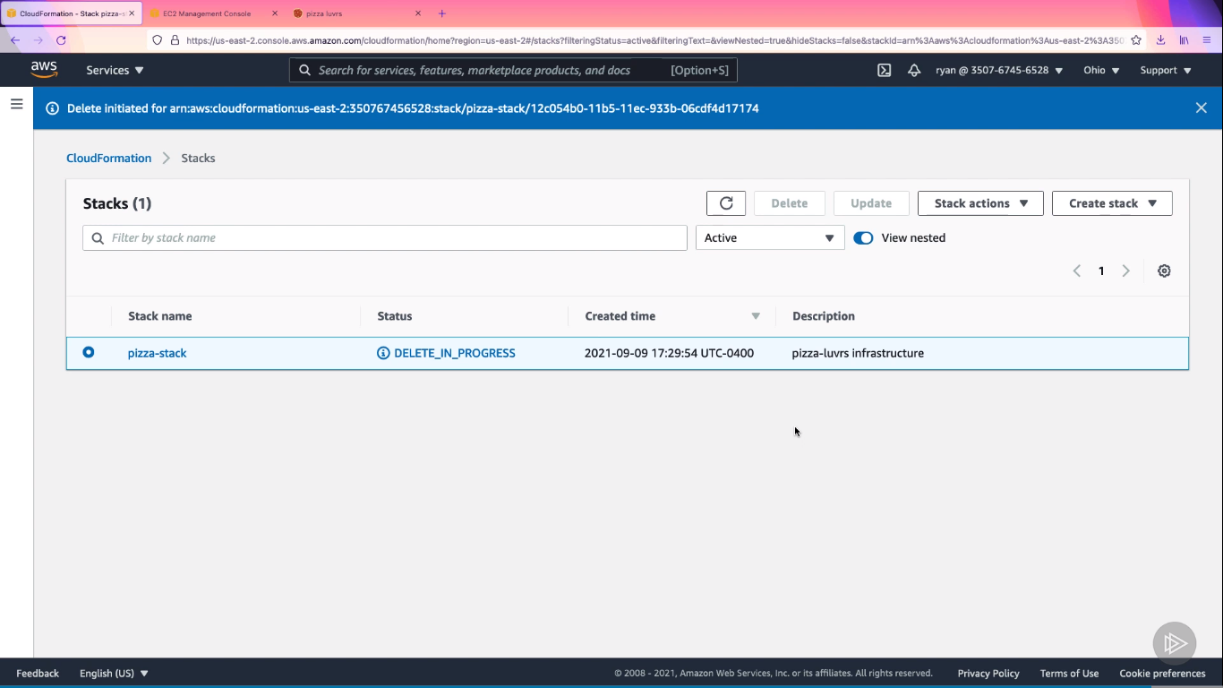**Elastic Beanstalk**

